Project Management Plan
1.0 Organizational Relationships and Reporting Structure of the XXX Center. To facilitate the research, education, and outreach activities of the XXX and provide a reporting structure for the XXX participants, we will organize the XXX’s administration through an executive committee (EC) consisting of the PI, major activities leads, and outreach leads; an external advisory committee (EAC); and a review committee. Center decisions will be coordinated through the leadership structure shown in fig. 1 to ensure that activities are aligned with the XXX’s core scientific vision. Three staff positions, a Center Manager, Administrative Assistant, and XXX will support the operations of the center. Table 1 highlights key management activities that are to be led by key personnel described below.
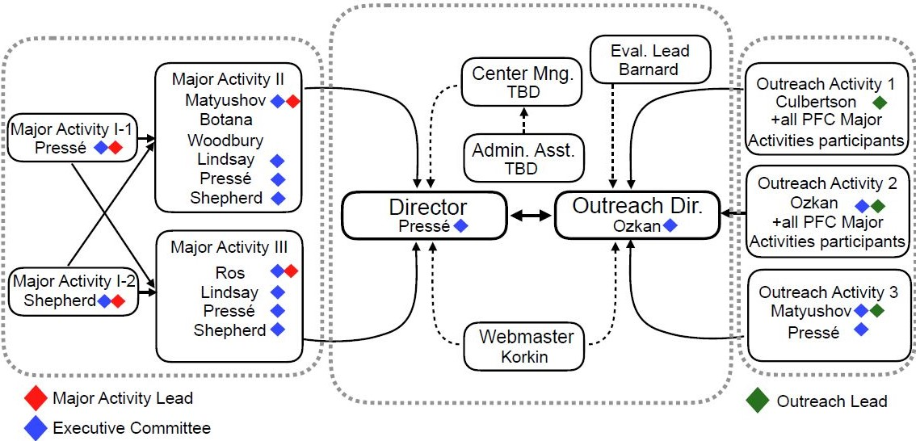
Figure 1: Center Organizational Chart
2.0 Processes for Activities
Key Personnel. XXX Center faculty are recognized internationally for their research and contributions to education and outreach activities with substantial overlap to this XXX Center’s main thrust. This Center integrates the long record of collaboration amongst the senior members in this proposal in fundamental processes across XXX (e.g., NAME, NAME) with complementary strengths in XXX and XXX and XXX brought by the new members (NAME, NAME).
Center Director. PI and Center Director XX will lead the XXX Center and will be responsible for all aspects of center operations, oversight of center activities, decision making, and facilitation of the Executive Committee. Additionally, the Center Director will meet with administrative staff monthly to address financial and administrative matters.
Major Activities Directors. Each Major Activity (MA) will be overseen by a designated MA Lead (see MA descriptions and Org Chart). Where there are multiple research teams under an MA, Research Team Leads will guide their progress and report to the MA Lead. Research teams will meet weekly and meetings will include postdoctoral scholars, graduate and undergraduate students. The MA Leads will serve as members of the EC.
Education, Outreach, and Diversity Director. The Education, Outreach, and Diversity (EOD) Director will oversee all education and outreach activities and interface with the Outreach Activity Leads who will work with all MA participants in the design and delivery of activities to ensure strong integration with research. The EOD Director will be primarily responsible for managing participant recruitment and the student application process for the summer undergraduate research program. The EOD Director will serve as a member of the Executive Committee.
3.0 Management and Leadership Mechanisms
The Executive Committee, consisting of the PI/Center Director XX, MA Leads, and the EOD Director will meet monthly to discuss progress and future activities and facilitate knowledge transfer and equipment sharing. PI/Center Director XX will coordinate Executive Committee meetings. Decision-making will be collaborative with PI XX resolving conflicts.
An External Advisory Committee will be appointed to advise leadership (Center Director and Executive Committee) on research, education, outreach, and diversity activities and help guide the Center leadership through decision-making and conflict resolution as needed.
Communication and Meetings. XXX Center faculty within and between Major Activities (see fig. 1) will meet weekly and leverage RU’s existing capabilities (e.g., Zoom, Box) to facilitate collaboration, and document sharing. We will build and maintain a public facing website to disseminate news, research results, and annual XXX. An annual all-hands meeting will include all participants.
Management Activities | Frequency
Major Activities team meetings | Weekly
Executive team meetings | Monthly
EAC meetings | Quarterly
Call for XXX | Annually
Review committee meetings | Annually
All-hands meeting | Annually
XXX updates | Monthly
Evaluation reports | Quarterly
Table 1: XXX Management Activities

Procedures and Criteria use to select, administer, and evaluate the Major Activities. In the first year, the Executive Committee will assess the Major Activities based on: 1) their ability to recruit strong and diverse student and postdoc candidates; 2) their ability to positively integrate initial scientific efforts into complementary XXX Major Activities. In subsequent years, the Executive Committee will use pooled input from the EAC’s quarterly meetings as well as research output (evaluated by the impact and relevance of products made public, invited talks given, stakeholder feedback) to assess funding of Major Activities.
Collaborative programs with other groups and institutions. All faculty involved in Major Activities have a strong history of collaboration with others in this proposal and beyond. New collaborators will be considered, as needed, at Major Activity team meetings. We have a small budget allowing for collaborators to travel to RU or faculty to visit collaborators.
Stakeholder co-creation of research agenda. PI and Major Activity leads will meet with stakeholder leads every XXX and get feedback on XXX by XXX and XXX. Scientific direction will be evaluated by XXX and XXX and quarterly meetings with XXX and XXX to elicit feedback on XXX and XXX will be held.
Management of changes for evolution of leadership structure. Starting in the second year of the Center the leadership structure will be evaluated by XXX and feedback will be requested from the executive committee, external committee members and a selection of stakeholders to provide feedback on structural, communication or XXX issues that may need to be addressed due to the evolving nature of the science and partnerships. The Center will also review the yearly recommended changes from the evaluator for Center structure and implement XXX and XXX to address XXX and XXX.
Educational and outreach activities. Leaders of the Outreach and Education activities (led by the EOD director) will plan and oversee implementation of education and outreach activities.
Evaluation. Evaluation of XXX Center education and outreach activities will be led by Dr. XXX through continuous monitoring and structured evaluation of activities. The evaluation team will attend leadership meetings to provide continuous feedback on the implementation and impact of the program, so challenges can be identified and mitigated in real time and successes of the program can be expanded.

4.0 Timeline and Milestones

